**Style Guide for A Great Presentation**

Mahasiswa kayak kita biasanya nggak mau ribet soal pakaian buat ke kampus. Kaos dan *jeans* selalu jadi pakaian wajib setiap harinya. Tapi nggak ada salahnya juga kok, *to put some efforts in your outfit for your important day at school. Here are 4 style guide for you to have a great speech or presentation in front of class:*

1. **A Little Formal Touch**

*Mix stripe tee with mom jeans and loafers.* Tambah sentuhan formal di *outfit* yang dipake lewat *blazer* dan *leather bag* buat ngilangin kesan yang terlalu kasual.

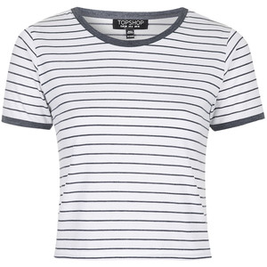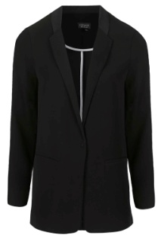

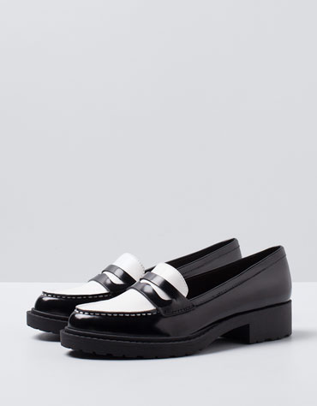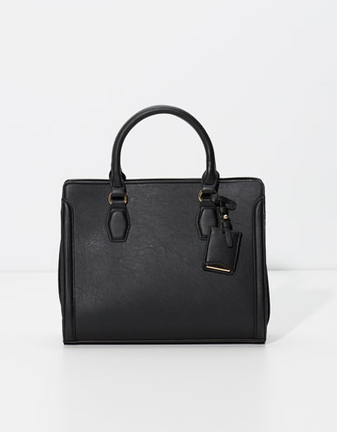

1. **Go Pastel**

*Pastel is the hottest tone color this Spring*. Paduin beberapa aksesoris berwarna pastel dengan *basic color outfit*.

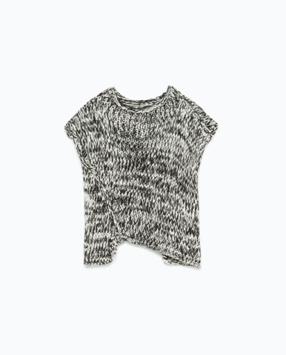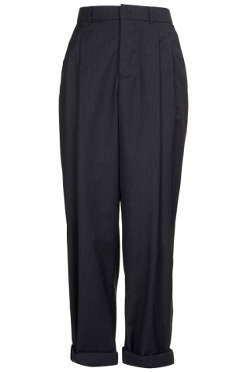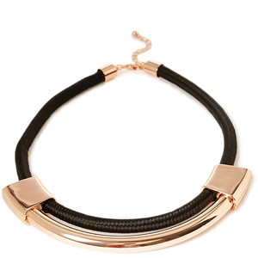

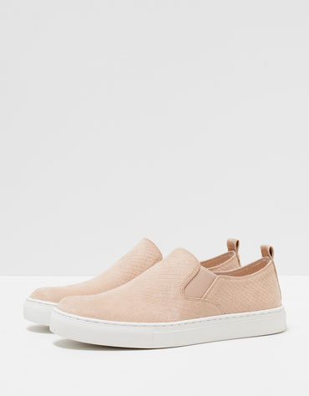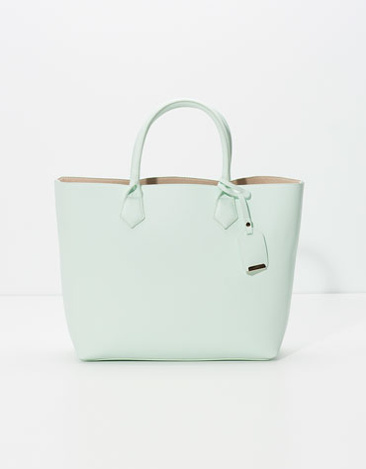

1. **Get Monochromatic**

*Outfit* dengan satu *tone* warna bikin kita keliatan *stunning* banget *and it’s a great way for us to draw some attentions by wearing an accessories in statement color.*

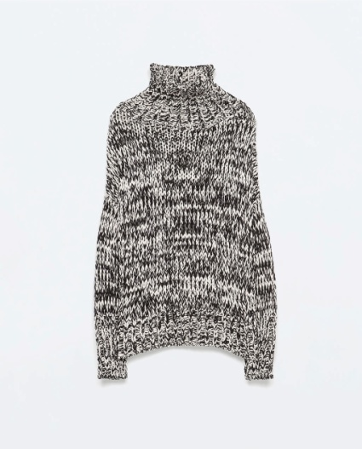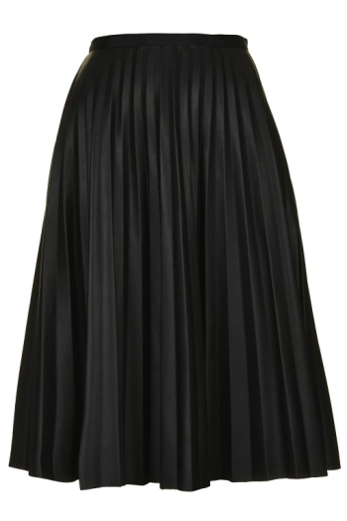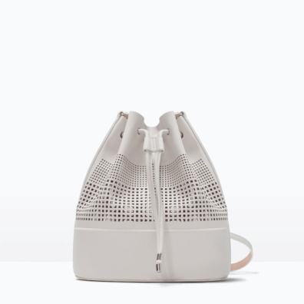

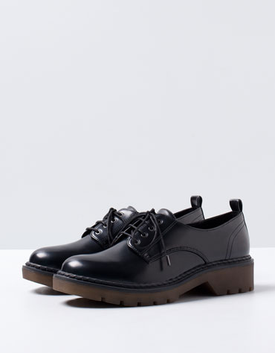

1. **Sporty Luxe**

*Mix sporty stuff, like jogger pants and sneakers, with white sweater and floral backpack. Put a sleeveless blazer over the sweater and necklace to get a luxe touch.*

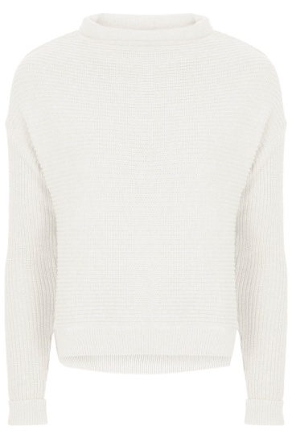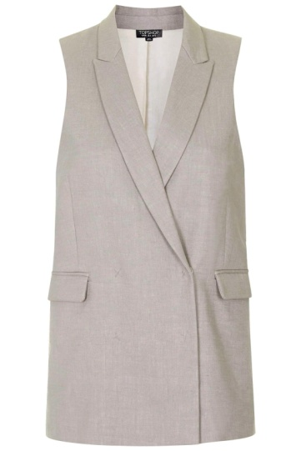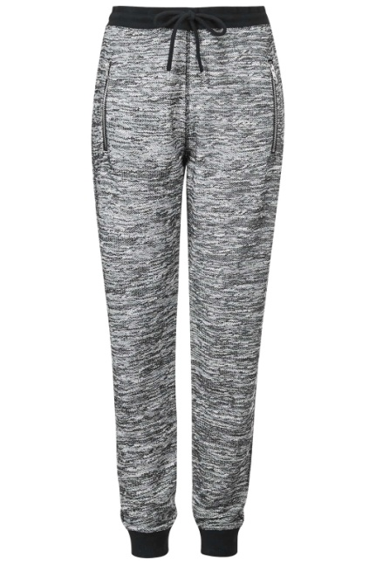

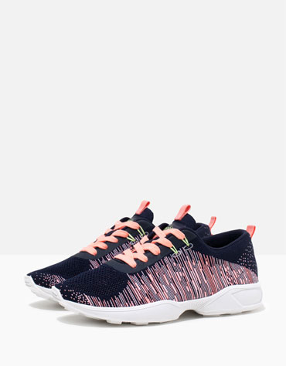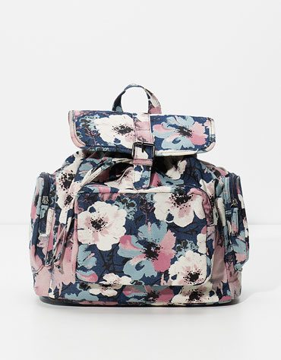

Wita Ervianda

Foto: berbagai sumber